Current computational power:
10^8 ops/sec.

If possible:
Generate all possible answers (unless there is a ‘source code size limit’) in the background and let other people use the computer.

RTE (Runtime Error): usually array sizes that are too small or stack overflow /infinite recursion errors.

Types of Error in Python:
- EOFError
- IndexError
- SyntaxError
- KeyError (access a key not in the dictionary)

Tips:
Try not to use math.dist() to calculate the distance in Kattis.

Compare File:
python .\marbletree.py < .\marbles_In.txt > out_temp99.txt && fc out_temp99.txt marbles_out.txt

Print the TILDE ~ (for golfing):
~x = - x - 1
-~x = x + 1
~-x = x -1
print("\u007E")

Finding if a number is odd in golfing:
if a&1:
print(f'{a} is odd')

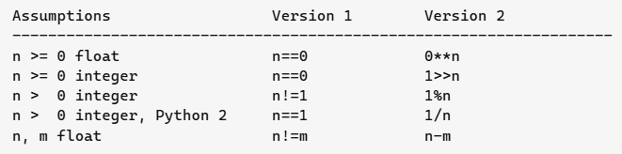
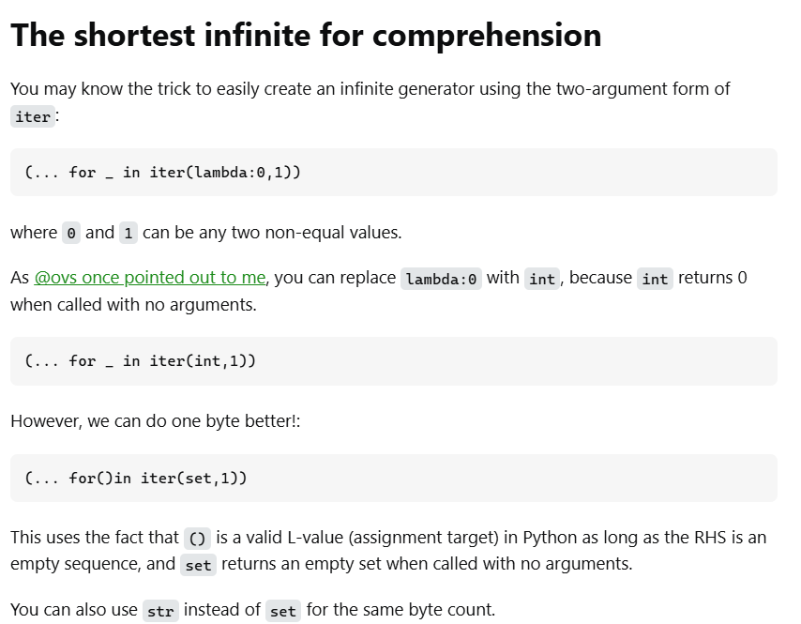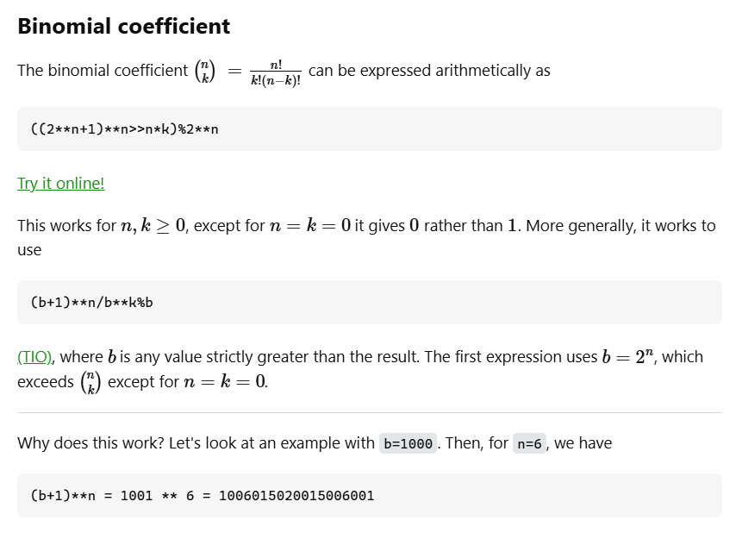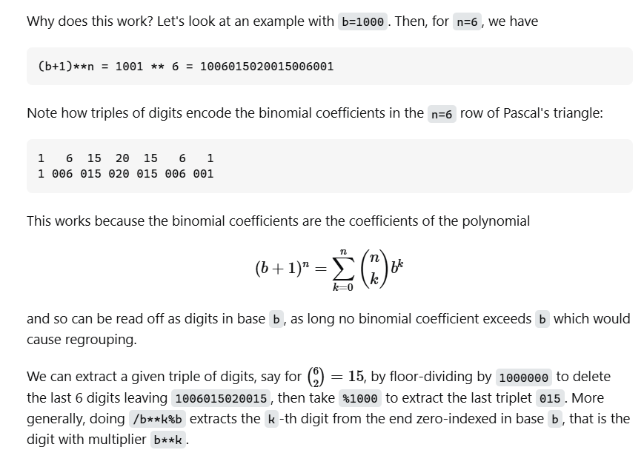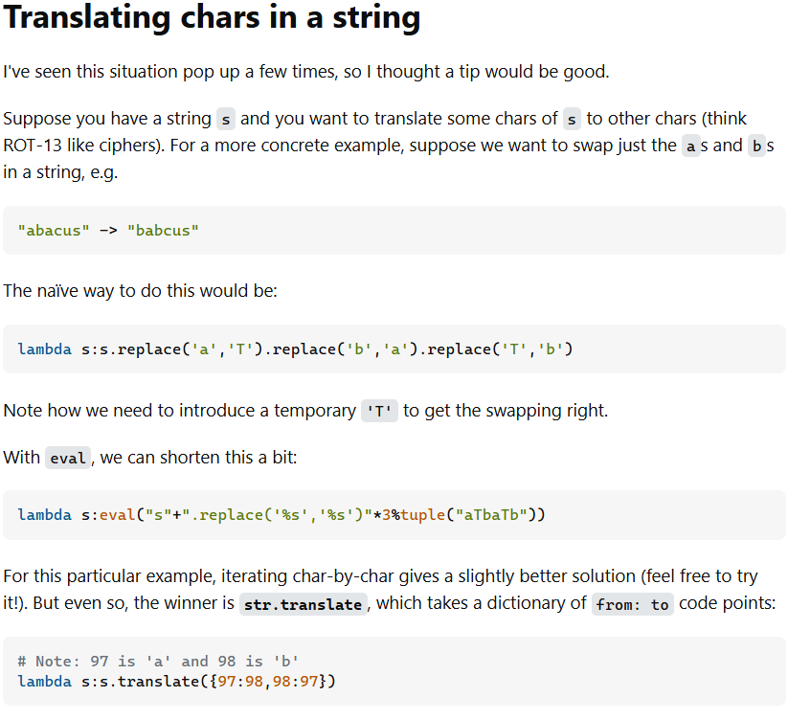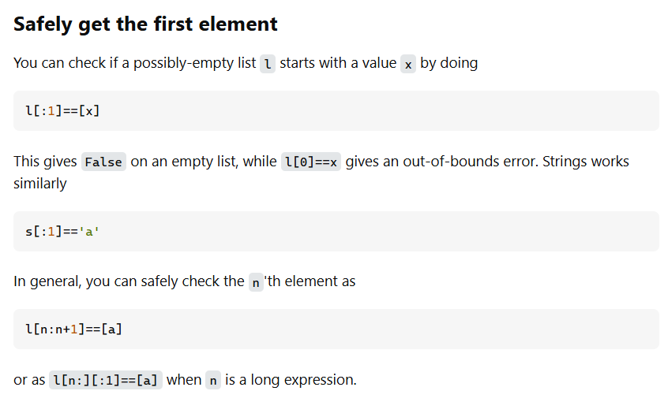
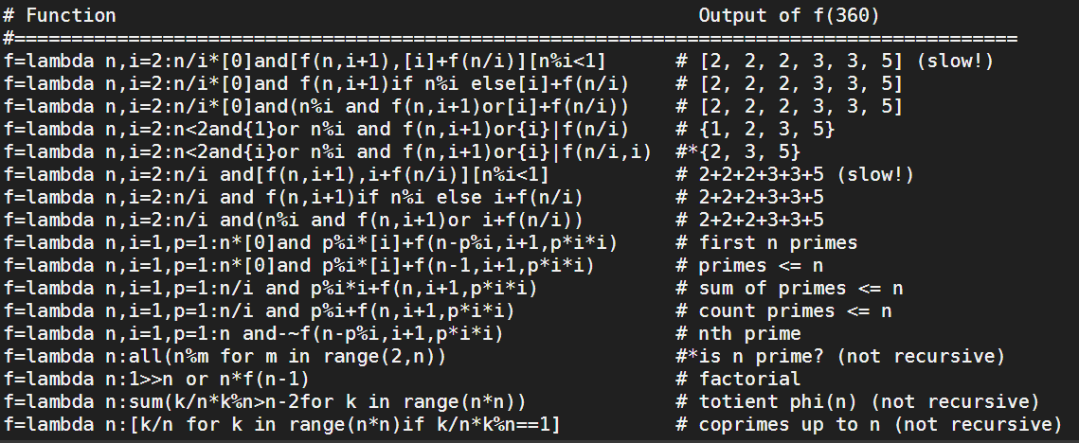
Read all input at once (for golfing):
a,b,*c=map(int,open(0).read().split())
a=[*open(0)] or a=open(0).read().split()

Use Sum() to flatten a list: as in this example:
from collections import*;print(*sum(([x]*y for x,y in sorted(Counter(open(0).read().split()[2:]).items(),key=lambda x:-x[1])),[]))
(and Counter can be sorted, it uses a different type of dictionary called defaultdict in collections)

Use random with weight:
import random
sampleList = [100, 200, 300, 400, 500]
randomList = random.choices(
sampleList, weights=(10, 20, 30, 40, 50), k=5)
print(randomList)

Turning mXn matrix to mXn matrix:
A = [(1,2,3),(4,5,6)] # list A = 2 tuples of 3
A = [*zip(*A)] # [(1,4),(2,5),(3,6)]

Use deque:
from collections import deque
my_deque = deque() # Empty deque
my_deque = deque([1, 2, 3]) # Deque initialized with values

Find All Matching Patterns:
from re import finditer
n="kakakawww"
print([a.start() for a in finditer("k",n)])

Fast Powering Algorithm:

def fast(b,p):
res=1
while p:
if p&1:res*=b
b*=b
p>>=1
return res

Find the primes:
#Sieve of Eratosthenes
from math import sqrt

def prime(n):
k=[True]*(n-2)
for i in range(2,int(sqrt(n))+1):
if k[i-2]==True:
j=i*i
while j<n:
k[j-2]=False
j+=i
return [i+2 for i in range(n-2) if k[i]==True]

1.3.4.1-Task5:
# print the day of the week of a given date and calculate the time passed
from datetime import date

def sortbirth(birthdates):

today = date.today()

def sortpara(indiv):
day, month, year = map(int,indiv.split())
obj_date = date(year,month,day)
age = today.year - obj_date.year - ((today.month,today.day)<(obj_date.month,obj_date.day))
return obj_date.month, obj_date.day, age

return sorted(birthdates,key=sortpara)

data = ["10 8 2010","9 8 2009","3 1 2020"]

print(sortbirth(data))

Print out day, month, year:
# 13025 - Back to the Past

from datetime import date

data = date(2013,5,29)
print(data.strftime("%B %d, %Y ") + data.strftime('%A'))
Output:
May 29, 2013 Wednesday
strftime(format): This method formats the date into a string according to the specified format codes. Some common format codes are:
- %Y: 4-digit year
- %m: 2-digit month (01-12)
- %d: 2-digit day (01-31)
- %B: Full month name (e.g., January, February)
- %b: Abbreviated month name (e.g., Jan, Feb)
- %A: Full weekday name (e.g., Monday, Tuesday)
- %a: Abbreviated weekday name (e.g., Mon, Tue)
Find week number:
from datetime import date

my_date = date(2006, 3, 15)

# Get the ISO year, week number, and weekday as a tuple
iso_calendar = my_date.isocalendar()
print(iso_calendar) # Output: (2006, 11, 3)

# Extract the week number
week_number = iso_calendar[1]
print(f"The week number for {my_date} is: {week_number}") # Output: The week number for 2006-03-15 is: 11

KMP All Pattern/Text Finding Algorithm - O(m+n):
t: text, p: pattern, r: all instances
def kmp(t,p):
n,m=len(t),len(p);l=[0]*m;j=0
if m<1:return[0]*(n>-1)
if n<1:return[]
for i in range(1,m):
while j and p[i]!=p[j]:j=l[j-1]
j+=p[i]==p[j];l[i]=j
i=j=0;r=[]
while i<n:
while i<n and j<m and t[i]==p[j]:i,j=i+1,j+1
if j==m:r+=[i-j];j=l[j-1]
elif j:j=l[j-1]
else:i+=1
return r

# Creating Regex Patterns: A Complete Guide

Regular expressions (regex) are powerful tools for pattern matching and text manipulation. This guide covers everything you should know when creating regex patterns, with a focus on Python's implementation.

## 1. Basic Syntax Elements

### Literal Characters
- Regular characters match themselves: `a` matches the letter "a"
- To match special characters like `.`, `*`, `?`, use a backslash to escape them: `\.`, `\*`, `\?`

### Metacharacters
These characters have special meanings in regex:
- `.` - Matches any single character except newline
- `^` - Matches start of string (or line with multiline mode)
- `$` - Matches end of string (or line with multiline mode)
- `*` - Matches 0 or more repetitions
- `+` - Matches 1 or more repetitions
- `?` - Matches 0 or 1 repetition
- `|` - Acts as an OR operator (alternation)
- `\` - Escapes special characters
- `[]` - Defines a character class
- `()` - Creates a capturing group

## 2. Character Classes

### Basic Character Classes
- `[abc]` - Matches any character in the set (a, b, or c)
- `[^abc]` - Matches any character NOT in the set
- `[a-z]` - Matches any character in the range (a through z)
- `[A-Z0-9]` - Matches uppercase letters and digits

### Shorthand Character Classes
- `\d` - Matches any digit (`[0-9]`)
- `\D` - Matches any non-digit (`[^0-9]`)
- `\w` - Matches any word character (`[a-zA-Z0-9_]`)
- `\W` - Matches any non-word character
- `\s` - Matches any whitespace (space, tab, newline)
- `\S` - Matches any non-whitespace character
- `\b` - Matches a word boundary
- `\B` - Matches a non-word boundary

## 3. Quantifiers

### Basic Quantifiers
- `*` - 0 or more (greedy)
- `+` - 1 or more (greedy)
- `?` - 0 or 1 (greedy)
- `{n}` - Exactly n times
- `{n,}` - n or more times
- `{n,m}` - Between n and m times

### Lazy (Non-greedy) Quantifiers
- `*?` - 0 or more (non-greedy)
- `+?` - 1 or more (non-greedy)
- `??` - 0 or 1 (non-greedy)
- `{n,}?` - n or more times (non-greedy)
- `{n,m}?` - Between n and m times (non-greedy)

## 4. Anchors and Boundaries

- `^` - Start of string/line
- `$` - End of string/line
- `\b` - Word boundary
- `\B` - Not a word boundary
- `\A` - Start of string (never matches at line breaks)
- `\Z` - End of string or before newline at the end
- `\z` - End of string

## 5. Groups and References

### Capturing Groups
- `(pattern)` - Captures the matched pattern in a group
- `(?:pattern)` - Non-capturing group

### Backreferences
- `\1`, `\2`, etc. - Refer to previously captured groups
- Example: `(\w+) \1` matches repeated words like "hello hello"

## 6. Lookaround Assertions

### Lookahead
- `(?=pattern)` - Positive lookahead: matches if pattern follows
- `(?!pattern)` - Negative lookahead: matches if pattern doesn't follow

### Lookbehind
- `(?<=pattern)` - Positive lookbehind: matches if pattern precedes
- `(?<!pattern)` - Negative lookbehind: matches if pattern doesn't precede

## 7. Alternation

- `pattern1|pattern2` - Matches either pattern1 or pattern2
- Example: `cat|dog` matches either "cat" or "dog"
- Use groups for complex alternations: `I love (cats|dogs)`

## 8. Flags/Modifiers

In Python's `re` module:

- `re.IGNORECASE` or `re.I`: Case-insensitive matching
- `re.MULTILINE` or `re.M`: `^` and `$` match start/end of each line
- `re.DOTALL` or `re.S`: `.` matches any character including newline
- `re.VERBOSE` or `re.X`: Allows comments and whitespace in pattern
- `re.ASCII` or `re.A`: Makes `\w`, `\b`, `\s`, etc. match only ASCII characters

## 9. Common Patterns

### Email validation
```python
r"[a-zA-Z0-9._%+-]+@[a-zA-Z0-9.-]+\.[a-zA-Z]{2,}"
```

### URL matching
```python
r"https?://(?:www\.)?[-a-zA-Z0-9@:%._\+~#=]{2,256}\.[a-z]{2,6}\b(?:[-a-zA-Z0-9@:%_\+.~#?&//=]*)"
```

### Phone numbers (US)
```python
r"\(?\d{3}\)?[-.\s]?\d{3}[-.\s]?\d{4}"
```

### Date (YYYY-MM-DD)
```python
r"\d{4}-(?:0[1-9]|1[0-2])-(?:0[1-9]|[12][0-9]|3[01])"
```

## 10. Best Practices

1. **Start simple and iterate**:
- Begin with basic patterns and refine them
- Test frequently with different inputs

2. **Readability matters**:
- Use Python's verbose mode (`re.VERBOSE`) for complex patterns
- Add comments to explain parts of complex patterns
```python
pattern = re.compile(r"""
\d{3} # Area code
[-.\s]? # Optional separator
\d{3} # First 3 digits
[-.\s]? # Optional separator
\d{4} # Last 4 digits
""", re.VERBOSE)
```
re.compile to save the time recompiling the pattern every time.

3. **Be specific**:
- Avoid using `.+` or `.*` when more specific patterns can work
- Use character classes to limit what can match

4. **Consider performance**:
- Avoid excessive backtracking with catastrophic backtracking patterns
- Limit use of lookarounds for complex patterns
- Use non-capturing groups `(?:...)` when you don't need the match

5. **Security considerations**:
- Don't use regex for parsing HTML/XML (use proper parsers)
- Be cautious with user-provided regex patterns

## 11. Python-Specific Tips

### Handling raw strings
- Always use raw strings (`r"pattern"`) to avoid escape sequence confusion

### Compiling for reuse
```python
pattern = re.compile(r"\d+") # More efficient for repeated use
matches = pattern.findall(text)
```

### Common functions
- `re.search()`: Finds the first match
- `re.match()`: Matches only at beginning of string
- `re.findall()`: Returns all non-overlapping matches as a list
- `re.sub()`: Substitutes matches with replacement text
- re.fullmatch: matches the full paragraph instead of just 1 line.

### Named groups
```python
pattern = r"(?P<year>\d{4})-(?P<month>\d{2})-(?P<day>\d{2})"
match = re.search(pattern, "2023-05-15")
if match:
print(match.group('year')) # 2023 #for the year only
print(match.group()) # for the literal match
```

## 12. Testing and Debugging Tools

- [Regex101](https://regex101.com/): Interactive regex tester with explanation
- [RegExr](https://regexr.com/): Visual regex testing with reference guide
- [PyRegex](http://www.pyregex.com/): Python-specific regex testing

## 13. Advanced Techniques

### Conditional patterns
```python
r"(?:(condition)?(?(1)then-pattern|else-pattern))"
```

### Recursive patterns
```python
r"(?P<parentheses>\((?:[^()]|(?&parentheses))*\))" # Matches nested parentheses
```

Remember: Regular expressions are powerful but can become complex quickly. When a pattern gets too complex, consider breaking the problem down into multiple steps or using parser libraries for structured formats.

Frogger (Union-Find):
from math import dist
from collections import deque
# Kruskal
# DFS
# DP

class Union_Find():
def __init__(self,n):
self.parents = [*range(n)]
self.rank = [0]*n
def find(self,x):
if self.parents[x]!=x:
self.parents[x]=self.find(self.parents[x])
return self.parents[x]
def union(self,x,y):
dx,dy=self.find(x),self.find(y)
if dx==dy:
return False
if self.rank[dx]>self.rank[dy]:
self.parents[dy] = dx
elif self.rank[dx]<self.rank[dy]:
self.parents[dx] = dy
else:
self.parents[dx]=dy
self.rank[dy]+=1
return True

counter = 1
while True:
n=int(input())
if n==0:break
points = [[*map(int,input().split())]for _ in range(n)]
input()
edges = []
for i in range(n):
for j in range(i+1,n):
edges.append((dist(points[i],points[j]),i,j))
edges.sort()
uf = Union_Find(n)
MST_edges = []
for edge in edges:
d,x,y = edge
if uf.union(x,y):
MST_edges.append(edge)
if len(MST_edges)==n-1:
break
MST_adjacency_list = [[]for _ in range(n)]
for d,x,y in MST_edges:
MST_adjacency_list[x].append((d,y))
MST_adjacency_list[y].append((d,x))
maxjump = [-1]*n
maxjump[0] = 0
myq = deque([0])
while myq:
curr = myq.popleft()
for d,p in MST_adjacency_list[curr]:
if maxjump[p]==-1:
maxjump[p] = max(maxjump[curr],d)
myq.append(p)
print(f"Scenario #{counter}")
counter+=1
print(f"Frog Distance = {maxjump[1]:.3f}")
print()

Fibonacci O(1) solution:
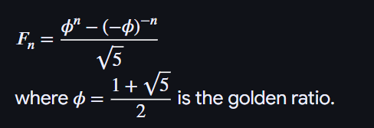

Finding the lens(or intersection) between 2 circles:
# Goats
from math import sqrt, acos, pi

def calc_middle(a,b,c,a2,b2,c2):return a2*acos((c2-b2+a2)/(2*c*a)) + b2*acos((c2-a2+b2)/(2*b*c)) - sqrt((c-a+b)*(c+a-b)*(a+b-c)*(c+a+b))/2

def BinarySearch(tries,min_a,max_a,b,c):
a = (min_a+max_a)/2
a2 = a**2
b2 = b**2
c2 = c**2
lhs = pi*b2
for _ in' '*tries:
# too far no intersect
if c>=a+b:
rhs = pi*a2
# c2 inside c1
elif a-b>=c and a>=b:
rhs = pi*(a2-b2)
# c1 inside c2
elif b>=a+c and b>=a:
rhs = 0
else:
rhs = pi*a2-calc_middle(a,b,c,a2,b2,c2)
if abs(rhs-lhs)<1e-9:
return a
if rhs>lhs:
max_a = a
else:
min_a = a
a = (max_a+min_a)/2
a2 = a**2
return a

for _ in' '*int(input()):
b,c = map(float,input().split())
a = BinarySearch(10000,0,2e9,b,c)
result = pi*a*a - (calc_middle(a,b,c,a*a,b*b,c*c) if c<a+b and abs(a-b)<c else (pi*b*b if a>=b and a-b>=c else 0))
print(f'{result} = {pi*b*b}, with a = {a}')

Fun fact about the sum of factorial:

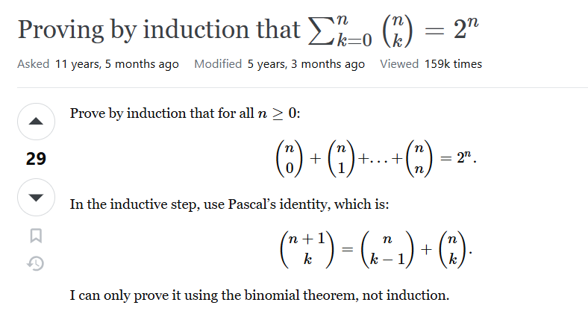

Debug Wrapper:
def debug_wrapper(func):
def wrapper(*args, **kwargs):
entry_color = "\033[94m" # Blue color
exit_color = "\033[92m" # Green color
reset_color = "\033[0m" # Reset color
print(f"{entry_color}Entering {func.__name__} with args: {args}, kwargs: {kwargs}{reset_color}")
result = func(*args, **kwargs)
print(f"{exit_color}Exiting {func.__name__} with result: {result}{reset_color}")
return result
return wrapper

@debug_wrapper
or

def debug_wrapper(func):
def wrapper(*args, **kwargs):
print(f"Entering {func.__name__} with args: {args}, kwargs: {kwargs}")
result = func(*args, **kwargs)
print(f"Exiting {func.__name__} with result: {result}")
return result
return wrapper

To solve parsers: recursive descent parser
Example:
# 10058 - Jimmi's Riddles

# python UVA_Problems/10058-Jimmis_Riddles.py < UVA_Problems/10058-Jimmis_Riddles_in.txt
# python 10058-Jimmis_Riddles.py < 10058-Jimmis_Riddles_in.txt
# python UVA_Problems/10058-Jimmis_Riddles.py < UVA_Problems/10058-Jimmis_Riddles_in.txt > UVA_Problems/10058-Jimmis_Riddles_out.txt

# python A.FORTESTONLY.py < UVA_Problems/10058-Jimmis_Riddles_in.txt > UVA_Problems/10058-Jimmis_Riddles_out.txt

# def debug_wrapper(func):
# def wrapper(*args, **kwargs):
# print(f"Entering {func.__name__} with args: {args}, kwargs: {kwargs}")
# result = func(*args, **kwargs)
# print(f"Exiting {func.__name__} with result: {result}")
# return result
# return wrapper

def debug_wrapper(func):
def wrapper(*args, **kwargs):
#print(f"Entering {func.__name__} with args: {args}, kwargs: {kwargs}")
result = func(*args, **kwargs)
#print(f"Exiting {func.__name__} with result: {result}")
return result
return wrapper

@debug_wrapper
def statement(string):
n = len(string)
i = 0
if string==[]:
return 0
next_index = action(string,i,n)
if next_index==-2 or next_index==n:
return 1
elif next_index==-1 :
return 0
elif next_index>i:
if next_index<n-1 and string[next_index]==',':
return statement(string[next_index+1:])
else:
return 0
return 0

@debug_wrapper
def action(string,i,n):
if i==n-1:
return -1
next_index = active_list(string,i,n)
if next_index==-2:
return -1
elif next_index==n-1:
return -1
if next_index>i:
i = next_index
else:return -1

next_index = verb(string,i,n)
if next_index==-2:
return -1
elif next_index==-1:
return -1
if next_index>i:
i = next_index
else:return -1

next_index = active_list(string,i,n)
if next_index==-2:
return -1
elif next_index==-1:
return -1
if next_index>i:
i = next_index
else:return -1
return i

@debug_wrapper
def active_list(string,i,n):
if i>n-1:
return -2
next_index = actor(string,i,n)
if next_index==-2:
return -2
elif next_index==-1:
return -1
if next_index>i:
i = next_index
else:return -1
while i<n and string[i]=='and':
i+=1
if i>=n:
return -1
next_index = actor(string,i,n)
if next_index==-2:
return -2
elif next_index==-1:
return -1
i = next_index
return i

@debug_wrapper
def actor(string,i,n):
nouns = ['tom','jerry','goofy','mickey','jimmy','dog','cat','mouse']
next_word = string[i]
if next_word in nouns:
return i+1
elif next_word in ['a','the']:
if i<n-1 and string[i+1] in nouns:
return i+2
else:
return -1
else:
return -1

@debug_wrapper
def verb(string,i,n):
verbs = ['hate','love','know','like','hates','loves','knows','likes']
if string[i] not in verbs:
return -1
return i+1

# i=0
while True:
try:
# i+=1
# print(f"Case {i}")
print(["NO I WON'T","YES I WILL"][statement(input().replace(',',' , ').split())])
except EOFError:
break

Dijkstra Algorithm with Min-heap implementation:
# Single source shortest path, non-negative weights

import heapq

while 1:
n,m,q,s = map(int,input().split())
if n==m==q==s==0:
break
graph = {k:set() for k in range(n)}
weightmap = {k:float('inf') for k in range(n)}
weightmap[s] = 0
myHeap = []
heapq.heapify(myHeap)
heapq.heappush(myHeap,(0,s))
for _ in range(m):
u,v,w = map(int,input().split())
graph[u].add((v,w))
while myHeap:
d,u = heapq.heappop(myHeap)
for v,w in graph[u]:
if w+d < weightmap[v]:
weightmap[v] = w+d
heapq.heappush(myHeap,(w+d,v))
for _ in range(q):
a = weightmap[int(input())]
print(a if a!=float('inf') else 'Impossible')

The Closest Pair Problem:
# 10245 - The Closest Pair Problem

# python UVA_Problems/10245-The_Closest_PairProblem.py < UVA_Problems/10245-The_Closest_PairProblem_in.txt
# python 10245-The_Closest_PairProblem.py < 10245-The_Closest_PairProblem_in.txt
from math import dist

while True:
n = int(input())
if n==0:exit()
coordinates = sorted([[*map(float,input().split())]for _ in' '*n])
if n==1:print('INFINITY');continue
d = dist(coordinates[0],coordinates[1])
if n==2:print('INFINITY' if d>=10000 else f'{d:.4f}');continue
for i in range(2,n):
p = i-1
new = coordinates[i]
while p>=0:
point = coordinates[p]
if abs(new[0]-point[0])<=d:
if abs(new[1]-point[1])<=2*d:
d = min(d,dist(new,point))
else:break
p-=1
print('INFINITY' if d>=10000 else f'{d:.4f}')

Finding divisibility using legendre’s formular:
# Factovisors

# python Factovisors.py < Factovisors_in.txt
#Sieve of Eratosthenes
from math import sqrt
from bisect import bisect_right

def prime(n):
k=[True]*(n-2)
for i in range(2,int(sqrt(n))+1):
if k[i-2]==True:
j=i*i
while j<n:
k[j-2]=False
j+=i
return [i+2 for i in range(n-2) if k[i]==True]
list_of_all_prime = prime(46340) #cuz m,n can get to 2^31

# Legendre's Formular (for finding the number of k factor)
def legendre(num,factor):
s=0
curr = factor
while num>=curr:
s+=num//curr
curr*=factor
return s

def check_divisible(a,b):
if a==0:
return b==1
if b==0:
return False
limit = bisect_right(list_of_all_prime,a)
factorized = {}
for factor in list_of_all_prime[:limit]:
factorized[factor]=legendre(a,factor)
# print(f"Factorized: {factorized}")
limit_b = bisect_right(list_of_all_prime,(b**0.5)//1+1)
for factor_b in list_of_all_prime[:limit_b]:
if b==1:
break
if b%factor_b==0:
count = 1
b = b//factor_b
while b%factor_b==0:
count+=1
b = b//factor_b
if factor_b not in factorized or count>factorized[factor_b]:
# print(f'Failed at: {factor_b}, count {count}')
return False
if b>a:
return False
else:
if b==1:
return True
else:
return b<=a

while True:
try:
a,b = map(int,input().split())
# a! vs. b
print(f'{b} divides {a}!'if check_divisible(a,b) else f'{b} does not divide {a}!')
except EOFError:
break

Longest Common Subsequence between n strings:

cases, length = map(int, input().split())
pos = [[0] * length for _ in range(cases)]
for i in range(cases):
curr_case = input()
for j in range(length):
pos[i][ord(curr_case[j]) - 65] = j

choices = [*range(length)]
choices.sort(key=lambda x: sum(pos[i][x] for i in range(cases)))

def one_instance(first, best_so_far):
curr_choices = [first] + [x for x in choices if x != first]
dp = [[0] * (cases + 1) for _ in range(length + 1)]
dp[0] = [0] + [-1] * cases
n = 0
for choice in curr_choices:
if dp[n][0] + (length - n) <= best_so_far: # Early exit
return dp[n][0]
options = [pos[i][choice] for i in range(cases)]
if all(x > y for x, y in zip(options, dp[n][1:])):
dp[n+1] = [dp[n][0] + 1] + options
else:
dp[n+1] = dp[n]
n += 1
return dp[n][0]

best = 0
for i in range(length):
best = max(best, one_instance(i, best))
print(best)

Karatsuba Algorithm (Divide n Conquer Multiplication):

# Python implementation of Karatsuba algorithm for bit string multiplication.

# Helper method: given two unequal sized bit strings, converts them to
# same length by adding leading 0s in the smaller string. Returns the
# the new length
def make_equal_length(str1, str2):
len1 = len(str1)
len2 = len(str2)
if len1 < len2:
for i in range(len2 - len1):
str1 = '0' + str1
return len2
elif len1 > len2:
for i in range(len1 - len2):
str2 = '0' + str2
return len1 # If len1 >= len2

# The main function that adds two bit sequences and returns the addition
def add_bit_strings(first, second):
result = "" # To store the sum bits

# make the lengths same before adding
length = make_equal_length(first, second)
carry = 0 # Initialize carry

# Add all bits one by one
for i in range(length-1, -1, -1):
first_bit = int(first[i])
second_bit = int(second[i])

# boolean expression for sum of 3 bits
sum = (first_bit ^ second_bit ^ carry) + ord('0')

result = chr(sum) + result

# boolean expression for 3-bit addition
carry = (first_bit & second_bit) | (second_bit & carry) | (first_bit & carry)

# if overflow, then add a leading 1
if carry:
result = '1' + result

return result

# A utility function to multiply single bits of strings a and b
def multiply_single_bit(a, b):
return int(a[0]) * int(b[0])

# The main function that multiplies two bit strings X and Y and returns
# result as long integer
def multiply(X, Y):
# Find the maximum of lengths of x and Y and make length
# of smaller string same as that of larger string
n = max(len(X), len(Y))
X = X.zfill(n)
Y = Y.zfill(n)

# Base cases
if n == 0: return 0
if n == 1: return int(X[0])*int(Y[0])

fh = n//2 # First half of string
sh = n - fh # Second half of string

# Find the first half and second half of first string.
Xl = X[:fh]
Xr = X[fh:]

# Find the first half and second half of second string
Yl = Y[:fh]
Yr = Y[fh:]

# Recursively calculate the three products of inputs of size n/2
P1 = multiply(Xl, Yl)
P2 = multiply(Xr, Yr)
P3 = multiply(str(int(Xl, 2) + int(Xr, 2)), str(int(Yl, 2) + int(Yr, 2)))

# Combine the three products to get the final result.
return P1*(1<<(2*sh)) + (P3 - P1 - P2)*(1<<sh) + P2

if __name__ == '__main__':
print(multiply("1100", "1010"))
print(multiply("110", "1010"))
print(multiply("11", "1010"))
print(multiply("1", "1010"))
print(multiply("0", "1010"))
print(multiply("111", "111"))
print(multiply("11", "11"))

How to accurately represent numbers in Python (for finance, etc.):
rounding to the 2nd decimal place in this example
from decimal import*

for _ in[0]*int(input()):
r,b,m= map(Decimal,input().split())
r /= 100
if (b*r).quantize(Decimal('0.01'),rounding=ROUND_HALF_UP)-m>=0:print('impossible');continue
for i in range(1200):
b += (b*r).quantize(Decimal('0.01'), rounding=ROUND_HALF_UP) - m
if b<=0:break
print(i+1 if b<=0 else'impossible')

fast fib (using matrix identity):
https://www.nayuki.io/page/fast-fibonacci-algorithms

memo = {0:0,1:1,2:1}
from math import sqrt

def fib(n):
if n in memo:
return memo[n]
# if n<=71:
# memo[n] = int(1/sqrt(5)*(((1+sqrt(5))/2)**n-((1-sqrt(5))/2)**n))%m
# return memo[n]
k = n//2
if n%2==0:
memo[n]=fib(k)*(2*fib(k+1)-fib(k))%m
return memo[n]
else:
memo[n]=(fib(k+1)**2 + fib(k)**2)%m
return memo[n]

a,b = map(int,input().split())
n = int(input())
m = 10**9+7
a,b = a%m,b%m
if n!=0:
f0 = fib(2*n-1)%m
f1 = fib(2*n)%m
f2 = (f0+f1)%m
print((a*f0+b*f1)%m,(a*f1+b*f2)%m)
else:
print(a,b)

Python reduce():

from functools import reduce

# Summing a list of numbers
numbers = [1, 2, 3, 4, 5]
sum_of_numbers = reduce(lambda x, y: x + y, numbers,1)
print(sum_of_numbers) # Output: 15

# Finding the product of elements
product = reduce(lambda x, y: x * y, numbers)
print(product) # Output: 120

Python filter:

# Filter even numbers from a list
numbers = [1, 2, 3, 4, 5, 6, 7, 8, 9, 10]

def is_even(num):
return num % 2 == 0

even_numbers_iterator = filter(is_even, numbers)
even_numbers = list(even_numbers_iterator)
print(even_numbers)
# Output: [2, 4, 6, 8, 10]

# Using a lambda function to filter vowels
letters = ['a', 'b', 'c', 'd', 'e']
vowels = ['a', 'e', 'i', 'o', 'u']

filtered_vowels_iterator = filter(lambda letter: letter in vowels, letters)
filtered_vowels = list(filtered_vowels_iterator)
print(filtered_vowels)
# Output: ['a', 'e']

The "splat" operator in Python refers to the use of * and ** symbols, primarily in function definitions and calls, to handle a variable number of arguments or to unpack iterables.
Here's a summarization of its uses:

1. *args (Packing Positional Arguments)
- Purpose: In a function definition, *args allows a function to accept an arbitrary number of positional arguments.
- Behavior: When *args is used, all extra positional arguments passed to the function are collected into a tuple. The name args is a convention; you can use any valid variable name preceded by *.
- Example (Function Definition):
- Python
def my_sum(*numbers):
total = 0
for num in numbers:
total += num
return total

my_sum(1, 2, 3) # numbers will be (1, 2, 3)
my_sum(10, 20, 30, 40) # numbers will be (10, 20, 30, 40)

2. **kwargs (Packing Keyword Arguments)
- Purpose: In a function definition, **kwargs allows a function to accept an arbitrary number of keyword arguments.
- Behavior: When **kwargs is used, all extra keyword arguments passed to the function are collected into a dictionary. The name kwargs is a convention; you can use any valid variable name preceded by **.
- Example (Function Definition):
- Python
def display_info(**details):
for key, value in details.items():
print(f"{key}: {value}")

display_info(name="Alice", age=30) # details will be {'name': 'Alice', 'age': 30}
display_info(city="New York", zip_code="10001", population=8_000_000)

3. Unpacking Arguments (in Function Calls)
The * and ** operators are also used to unpack iterables (lists, tuples, dictionaries) when calling a function, allowing their elements to be passed as individual arguments.
- *iterable (Unpacking for Positional Arguments):
  - Used with lists or tuples. It unpacks the elements of the iterable, passing them as separate positional arguments to the function.
  - Example:
  - Python
def add(a, b, c):
return a + b + c

my_list = [1, 2, 3]
add(*my_list) # Equivalent to add(1, 2, 3)

- **dictionary (Unpacking for Keyword Arguments):
  - Used with dictionaries. It unpacks the key-value pairs of the dictionary, passing them as separate keyword arguments to the function.
  - Example:
  - Python
def print_person(name, age):
print(f"Name: {name}, Age: {age}")

person_data = {"name": "Bob", "age": 25}
print_person(**person_data) # Equivalent to print_person(name="Bob", age=25)

4. Order of Arguments in Function Definitions
When combining these special arguments with regular arguments, a specific order must be followed:
- Standard positional arguments
- Positional-only arguments (introduced by /, if used)
- *args (to capture extra positional arguments)
- Standard keyword-only arguments (following * or *args)
- **kwargs (to capture extra keyword arguments)
Correct Order Example:
Python
def example_function(pos1, pos2, /, pos_or_kw, *args, kw_only1, **kwargs):
pass

Key Benefits:
- Flexibility: Functions can handle a varying number of inputs without needing multiple overloads.
- Readability: Explicitly naming keyword arguments improves code clarity.
- Code Reusability: Functions become more versatile.
The initial website could not be accessed, so this summary is based on general Python documentation and common usage examples of the splat operator and argument packing/unpacking, as sourced from:
- *args and *kwargs in Python - GeeksforGeeks
- Python args and kwargs: Demystified - Real Python
- *How To Use *args and *kwargs in Python 3 - DigitalOcean
- Packing and Unpacking Arguments in Python - Shiksha Online
- What is packing and unpacking of arguments in Python? - Educative.io

Python LRU Cache (for memoization):
from functools import lru_cache

@lru_cache
def is_palindrome(word):
if len(word) in [0,1]:
return True
if word[0]==word[-1]:
return is_palindrome(word[1:-1])
return False

Python Enum (for a type that accepts special infos):

from enum import Enum

Color = Enum('Color', [('RED',1), ('GREEN',2), ('BLUE',3)])
print(Color.RED.name) # this works, prints 'Color.RED'
print(Color.RED) # this works, prints 'Color.RED'
print(Color.RED.value) # this works, prints '1'
print(Color.TEAL) # this raises an exception

or

from enum import Enum

class Color(Enum):
RED = 1
GREEN = 2
BLUE = 3

Python match and case:
def get_hex(color):
match color:
case Color.RED:
return "#FF0000"
case Color.GREEN:
return "#00FF00"
case Color.BLUE:
return "#0000FF"

# default case
# (invalid Color)
case _:
return "#FFFFFF"

or

def get_hex(color, shade):
match (color, shade):
case (Color.RED, Shade.LIGHT):
return "#FFAAAA"
case (Color.RED, Shade.DARK):
return "#AA0000"
case (Color.GREEN, Shade.LIGHT):
return "#AAFFAA"
case (Color.GREEN, Shade.DARK):
return "#00AA00"
case (Color.BLUE, Shade.LIGHT):
return "#AAAAFF"
case (Color.BLUE, Shade.DARK):
return "#0000AA"

# default case
# (invalid combination)
case _:
return "#FFFFFF"

combine Enum with match:

from enum import Enum

class DocFormat(Enum):
PDF = 1
TXT = 2
MD = 3
HTML = 4

# don't touch above this line

def convert_format(content, from_format, to_format):
match (from_format,to_format):
case (DocFormat.MD,DocFormat.HTML):
return f"<h1>{content[2:]}</h1>"
case (DocFormat.TXT,DocFormat.PDF):
return f"[PDF] {content} [PDF]"
case (DocFormat.HTML,DocFormat.MD):
return content.replace("<h1>","# ").replace("</h1>","")
case _:
raise Exception("invalid type")

Kahn Topological Sort:
# Hacky Ordering
# https://open.kattis.com/problems/hackyordering

from collections import defaultdict,deque

strings = [input().strip() for _ in ' '*int(input())]

class Trie_Node:
def __init__(self):
self.children = dict()
self.end = False

def build_Trie(strings:list)->Trie_Node|None:
root = Trie_Node()
for string in strings:
current_level = root
for character in string:
if character not in current_level.children:
current_level.children[character] = Trie_Node()
current_level = current_level.children[character]
if current_level.children:
return None
current_level.end = True
return root

def build_constraint_graph(strings):
graph = defaultdict(list)
indeg = {chr(ord('a')+i):0 for i in range(26)}
for i in range(len(strings)-1):
s1,s2 = strings[i],strings[i+1]
minimum_length = min(len(s1),len(s2))
diff = False
for j in range(minimum_length):
if s1[j]!=s2[j]:
u,v = s1[j],s2[j]
if v not in graph[u]:
graph[u].append(v)
indeg[v] += 1
diff = True
break
if not diff:
if len(s1) > len(s2):
return None
return indeg,graph

def kahn_top_sort(strings:list):
root = build_Trie(strings)
if root is None:
return None
build_constaint_ouput = build_constraint_graph(strings)
if build_constaint_ouput is None:
return None
indeg,graph = build_constaint_ouput
q = deque(c for c in indeg if indeg[c]==0)
order = []
while q:
u = q.popleft()
order.append(u)
for v in graph[u]:
indeg[v] -= 1
if indeg[v] == 0:
q.append(v)
if len(order)==26:
return ''.join(order)
else:
return None

result = kahn_top_sort(strings)
print(result if result is not None else 'impossible')

Longest Common Subsequence:
# A Naive recursive implementation of LCS problem

# Returns length of LCS for s1[0..m-1], s2[0..n-1]
def lcsRec(s1, s2, m, n):

# Base case: If either string is empty, the length of LCS is 0
if m == 0 or n == 0:
return 0

# If the last characters of both substrings match
if s1[m - 1] == s2[n - 1]:

# Include this character in LCS and recur for remaining substrings
return 1 + lcsRec(s1, s2, m - 1, n - 1)

else:
# If the last characters do not match
# Recur for two cases:
# 1. Exclude the last character of S1
# 2. Exclude the last character of S2
# Take the maximum of these two recursive calls
return max(lcsRec(s1, s2, m, n - 1), lcsRec(s1, s2, m - 1, n))

def lcs(s1,s2):
m = len(s1)
n = len(s2)
return lcsRec(s1,s2,m,n)

if __name__ == "__main__":
s1 = "AGGTAB"
s2 = "GXTXAYB"
print(lcs(s1, s2))

Huffman Code:
# Python program for the above approach:
import heapq

# Class to represent huffman tree
class Node:
def __init__(self, x):
self.data = x
self.left = None
self.right = None

def __lt__(self, other):
return self.data < other.data

# Function to traverse tree in preorder
# manner and push the huffman representation
# of each character.
def preOrder(root, ans, curr):
if root is None:
return

# Leaf node represents a character.
if root.left is None and root.right is None:
ans.append(curr)
return

preOrder(root.left, ans, curr + '0')
preOrder(root.right, ans, curr + '1')

def huffmanCodes(s, freq):
# Code here
n = len(s)

# Min heap for node class.
pq = []
for i in range(n):
tmp = Node(freq[i])
heapq.heappush(pq, tmp)

# Construct huffman tree.
while len(pq) >= 2:
# Left node
l = heapq.heappop(pq)

# Right node
r = heapq.heappop(pq)

newNode = Node(l.data + r.data)
newNode.left = l
newNode.right = r

heapq.heappush(pq, newNode)

root = heapq.heappop(pq)
ans = []
preOrder(root, ans, "")
return ans

Fenwick Tree aka Binary Index Tree:

# Python implementation of Binary Indexed Tree

# Returns sum of arr[0..index]. This function assumes
# that the array is preprocessed and partial sums of
# array elements are stored in BITree[].
def getsum(BITTree,i):
s = 0 #initialize result

# index in BITree[] is 1 more than the index in arr[]
i = i+1

# Traverse ancestors of BITree[index]
while i > 0:

# Add current element of BITree to sum
s += BITTree[i]

# Move index to parent node in getSum View
i -= i & (-i)
return s

# Updates a node in Binary Index Tree (BITree) at given index
# in BITree. The given value 'val' is added to BITree[i] and
# all of its ancestors in tree.
def updatebit(BITTree , n , i ,v):

# index in BITree[] is 1 more than the index in arr[]
i += 1

# Traverse all ancestors and add 'val'
while i <= n:

# Add 'val' to current node of BI Tree
BITTree[i] += v

# Update index to that of parent in update View
i += i & (-i)

# Constructs and returns a Binary Indexed Tree for given
# array of size n.
def construct(arr, n):

# Create and initialize BITree[] as 0
BITTree = [0]*(n+1)

# Store the actual values in BITree[] using update()
for i in range(n):
updatebit(BITTree, n, i, arr[i])

# Uncomment below lines to see contents of BITree[]
#for i in range(1,n+1):
# print BITTree[i],
return BITTree

# Driver code to test above methods
freq = [2, 1, 1, 3, 2, 3, 4, 5, 6, 7, 8, 9]
BITTree = construct(freq,len(freq))
print("Sum of elements in arr[0..5] is " + str(getsum(BITTree,5)))
freq[3] += 6
updatebit(BITTree, len(freq), 3, 6)
print("Sum of elements in arr[0..5]"+
" after update is " + str(getsum(BITTree,5)))

